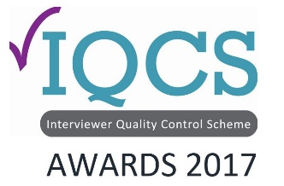
Awards Application Form

Fieldwork Excellence -Face to Face or Telephone Award

Please send the completed form attached to an email to the IQCS administrator Gill Wareing: gill@iqcs.org. Closing date for applications is end of day, October 20th 2017.

Submission Title (will be used in publications)
Company name:
Entrant details
Name
Position
Telephone |  | Mobile
Email

Fieldwork Excellence Awards Application – Face to Face or Telephone
The cost of entry is £75 per submission. Organizations are limited to 1 entry per category.
This award celebrates the best in Face-to-Face or Telephone data-collection.
We are looking for a case study of a recent project, which you were particularly proud of. The case study of a recent project should demonstrates how your organisation achieved fieldwork excellence in completing a particularly challenging project.
What the judges are looking for:
- Robust data-collection
- High quality interviewing
- Going the extra mile to complete a challenging project
- Delivering excellence to your internal/external client
- Demonstration the importance of great quality assurance processes underpinning the data-collection process

Submission Statement (Up to 500 words)

Testimonials (Please provide up to three testimonials)

Additional Anecdotes

Submission Date and Entrant Signature
Date:

Signature:

