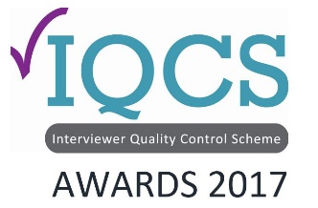
Awards Application Form

Interviewer Excellence -Telephone Award

Please send the completed form attached to an email to the IQCS administrator Gill Wareing: gill@iqcs.org. Closing date for applications is end of day, October 20th 2017.

Submission Title (will be used in publications)
Company name:
Entrant details
Name
Position
Telephone |  | Mobile
Email

Interviewer Excellence Awards Application – Telephone
The cost of entry is £75 per submission. Organizations are limited to 1 entry per category.

The award celebrates the unsung Heroes of Quality, those individuals or teams who are making quality an integral part of the data-collection process.
What the judges are looking for:
• Dedication to quality
• Consistently high standard of interviewing
• Robust data-collection
• Going the extra mile to complete a challenging project or projects
• Delivering excellence to your internal/external client

We are looking for an individual or team in telephone operations who have demonstrated that they go the extra mile in delivering interviewing excellence.

Submission Statement (Up to 500 words)

Testimonials (Please provide up to three testimonials)

Additional Anecdotes

Submission Date and Entrant Signature
Date:

Signature:

