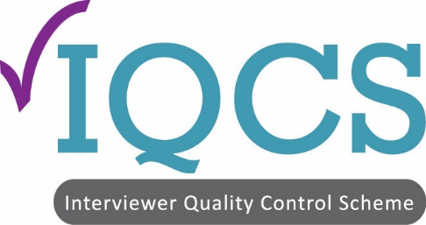 | Interviewer Quality Control Scheme  6 Walkfield Drive  Epsom Downs, Surrey, KT18 5UF  Telephone: 07935 057275  Email: gill@iqcs.org  Website: www.iqcs.org

INTERVIEWER QUALITY CONTROL SCHEME FEES FOR 2018 INSPECTIONS (FOR MEMBERSHIP IN 2019)

Annual Membership Fee £495

On receipt of this Annual Fee form, members will be advised of their inspection fee and invoiced for both membership and inspection fees.

Fees will be based on total number of groups and/or face-to-face fieldwork days and/or telephone hours conducted, plus the number of methodologies undertaken in a calendar year. Also the number of sites to be visited will be taken into consideration.

Name of Company:

Write in
Total number of fieldwork days conducted since your last inspection or in the last six months, if this is your first inspection

Total number of groups conducted since your last inspection or in the last six months, if this is your first inspection

Total number of hours conducted in the telephone unit/s since your last inspection or in the last six months, if this is your first inspection

 | Types of work undertaken
Quantitative – face to face | Yes/No
Qualitative | Yes/No
Telephone | Yes/No
Mystery shopping | Yes/No
Auditing | Yes/No

Number of sites required to be visited
Give details of addresses:

